The Five Critical Functions of Leadership
- Making Things Happen
'Leadership is not necessarily a title or a powerful position; it is a process, it is relational, it is making something happen, it is leaving a mark.’
-Larraine Matusak

‘A leader’s task is to open doors and windows.’
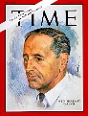
-John W. Gardiner

- Creating Vision and Inspiration
If any one idea about leadership has inspired organisations and communities for thousands of years, it is the capacity to hold a shared picture of the future we seek to create’
-Peter Senge

‘If your actions inspire others to dream more, learn more and become more, you are a leader.’
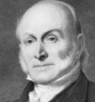
-John Quincey Adams

‘Leadership is that special quality which enables people to stand up and pull the rest of us over the horizon
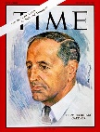
-John W. Gardiner
3. Facilitating Collaboration
‘I can’t save the world on my own…it will take at least three of us.’
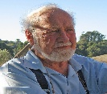
- Bill Mollison

‘If you want to go faster, go alone. If you want to go further, go together.’
- African Proverb

- Instilling a positive Mindset
‘The first duty of a leader is to instill optimism.’
- Field Marshall Bernard Montgomery 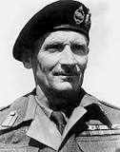
‘A leader is a merchant of hope’
- Napoleon 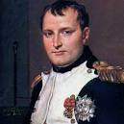
‘You can’t move your town to a different location, you can move your town’s attitude in a different direction’
-Heartland Center for Leadership Development
5. Fostering Leadership
‘A leader creates leaders who creates leaders.’
- Carol McCall
‘Leaders don’t create followers – they create more leaders’
- Tom Peters 